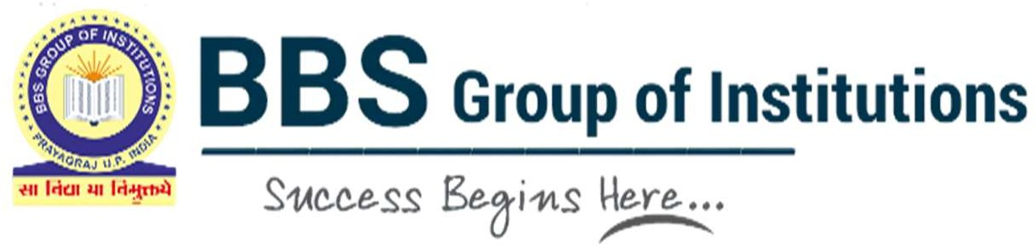

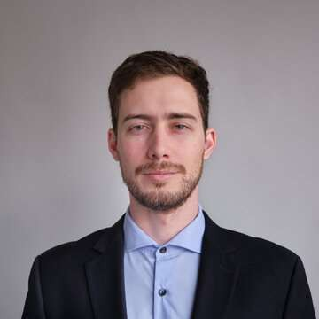
Ayush Verma
Mobile No: 1234567890
Email: ayushxyz@gmail.com

OBJECTIVE A dedicated learner and an MBA scholar looking for an entry-level opportunity at an esteemed organisation to utilise my knowledge and skills which are conducive to learning and will contribute to the overall business strategy of the organization, along with my own personal and professional growth.

EDUCATION
Qualification | Board/University | Institution  Name | Year of  Passing | Percentage  Secured
MBA | AKTU, Lucknow | BBS College of Engg. & Technology, Prayagraj | 2024 | 75.50%  (1st Year)
Graduation (B.Com.) | University of Allahabad | CMP Degree College, Prayagraj | 2021 | 62.63%
Intermediate | CBSE | Allahabad Public School | 2018 | 78.25%
High School | CBSE | Allahabad Public School | 2016 | 89.3%

TECHNICAL SKILLS

COMPUTER SKILLS
- CCC (Course on Computer Concepts)
- Data Analysis
- Presentation and Design
- Technical Writing

- MS Word, MS PowerPoint, MS Excel, Web Browsing, Emailing, Social Media Handling

WORKSHOP • Attended Soft Skills Development Programme by
Mahindra Pride Classroom (MPC)’2022.
  - Attended a 2-day virtual workshop on Universal Human Values & Professional Ethics organized by Jaipuria Institute of Management, Ghaziabad’2023.

CERTIFICATION AND ADDITIONAL COURSES

EXTRACURRICULAR ACTIVITIES

ACHIEVEMENTS

HOBBIES
- Virtual Internship with CollegeTips in Social Media Handling and Content Creation’2021(www.collegetips.in)
- Certified as Six Sigma Yellow Belt Professional at 6SIGMAstudy, a global certification body.

- Participated in Group Dance in a freshers’ party at BBS College of Engg. & Technology, Prayagraj.
- Served as Head-Coordinator, managed and anchored a guest lecture in behavioural finance by Prof. Dr. Ranjeet Singh, IIIT-Allahabad. (2022)
- Participated in Business Quiz in Adharshila-2022, a business & cultural event at School of Management Sciences, Varanasi.
- Management and anchored an event on Cyber Crime organized by Indian Army at North Central Zone Cultural Center (NCZCC), Prayagraj’2021.

- Participated and won 1st prize in Shark Tank - 2022, an event for young entrepreneurs, organized by Dept. of MBA and Corporate Resource Center – Imperial College, Nasik.
- Participated and won 1st prize in Debate Competition’2022 in Rotary Club Annual Fest held at AMA-Prayagraj.

- Reading novels (fiction & non-fiction)
- Traveling
- Social welfare
- Content creation

STRENGTHS • Excellent written and verbal communication
  - Research skills
  - Cross cultural competency
  - Passion for continuous learning
  - Good observational skills
  - Ability to resolve conflicts
  - Strategic thinking

PERSONAL DETAILS • Father’s Name - Mr. Rajesh Verma
  - Mother’s Name- Mrs. Kalpana Verma
  - Date of Birth - 7th March 2001
  - Nationality - Indian
  - Marital Status - Unmarried
  - Languages Known- Hindi, English
  - Address - 244/7B/3 Vikas Vihar Colony,
Prayagraj (U.P.) PIN - 211015

DECLARATION I hereby declare that the above mentioned details are true to the best of my knowledge.

Date:
Place: Prayagraj Ayush Verma

